DEPARTMENT OF INFORMATION TECHNOLOGY
A
SEMINAR REPORT
ON
An IOT-Based User-Centric Ecosystem for Heterogeneous Smart Home Environments

OF
T.E. ( INFORMATION TECHNOLOGY )
(Academic Year: 2015-2016)

SUBMITTED BY

Mr. Tejas Naik (3043)
Mr. Sarvanan G. (3059)
Mr. Smit Sheth (3064)
Mr. Abhinav Shirore (3067)

Group No. 13

GUIDED BY

Prof. Tushar Rane



Society for Computer Technology & Research’s
PUNE INSTITUTE OF COMPUTER TECHNOLOGY
S. No. 27, Dhankawadi, Pune Satara Road, Pune – 411043.
Savitibai Phule University of Pune
(2015-2016)

Society for Computer Technology & Research’s
PUNE INSTITUTE OF COMPUTER TECHNOLOGY
S. No. 27, Dhankawadi, Pune Satara Road, Pune – 411043.
Department Of Information Technology

CERTIFICATE

This is to certify that a seminar entitled

“An IOT-Based User-Centric Ecosystem for Heterogeneous Smart Home Environments”

has been completed by Mr. Tejas Naik (3043), Mr. Sarvanan G (3059), Mr. Smit Sheth (3064), Mr. Abhinav Shirore (3067), [Group ID : 13] of TE IT in the Semester - II of academic year 2015-2016 in partial fulfillment of the Third Year of Bachelor degree in “Information Technology” as prescribed by the Savitribai Phule University of Pune.

(Prof.T. A. Rane) (Prof.T. A. Rane ) (Dr.Emmanuel M)
Seminar Guide Seminar Coordinator HOD IT

Place: PICT, Pune
Date: 01/ 03 / 2016

ACKNOWLEDGEMENT

It gives me great pleasure and satisfaction in presenting this seminar on “An IOT-Based User-Centric Ecosystem for Heterogeneous Smart Home Environments”

I would like to express my deep sense of gratitude towards Prof. P.T. Kulkarni, Principal, Pune Institute of Computer Technology, Pune for providing the necessary infrastructure to complete this task.

I would like to give thanks to Dr. Emmanuel M. Head of the Department, Information Technology.

My special thanks to project guide Prof. Tushar Rane, Department of Information Technology, for helping me throughout and guiding me from time to time.

I would like to thank all those, who have directly or indirectly helped me for the completion of the work during this seminar.

Mr. Tejas Naik (3043)
Mr. Sarvanan G (3059)
Mr. Smit Sheth (3064)
Mr. Abhinav Shirore (3067)

CONTENTS
Ch No. | Name Of Topic |  |  |  |  | Page
 | ABSTRACT |  |  |  |  | I
 | LIST OF FIGURES |  |  |  |  | II
 | LIST OF ABBREVIATIONS |  |  |  |  | IV
1 | INTRODUCTION |  |  |  |  | 1-3
 | 1.1 | Motivation |  |  |  | 3
 | 1.2 | Problem Statement |  |  |  | 3
 | 1.3 | Scope |  |  |  | 3
2 | LITERATURE SURVEY |  |  |  |  | 4-11
 | 2.1 | INTRODUCTION |  |  |  | 4
 | 2.2 | THE SMART-CONDO: OPTIMIZING SENSOR PLACEMENT FOR INDOOR LOCALIZATION |  |  |  | 5
 |  | 2.2.1 |  | INTRODUCTION |  | 5
 |  | 2.2.2 |  | NP-HARDNESS AND APPROXIMATION ALOGORITHM |  | 6
 | 2.3 | INFORMATION CENTRIC NETWORKING |  |  |  | 7
 |  | 2.3.1 | INTRODUCTION |  |  | 7
 |  | 2.3.2 | ICN FRAMEWORK: |  |  | 7
 | 2.4 | MACHINE TO MACHINE COMMUNICATION (M2M) |  |  |  | 9
 |  | 2.4.1 |  | INTRODUCTION |  | 9
 | 2.5 | EASYCONNECT |  |  |  | 10
 |  | 2.5.1 |  |  | INTRODUCTION | 10
3 | Discussion and Analysis |  |  |  |  | 12-20
 | 3.1 OVERVIEW |  |  |  |  | 12
 | 3.2 EXPLICATION |  |  |  |  | 12
4 | CONCLUSION AND FUTURE SCOPE |  |  |  |  | 21
 | 4.1 | CONCLUSION |  |  |  | 21
 | 4.2 | Future Scope (PROBLEM DEFINITION) |  |  |  |  | 21
5 | REFERENCES |  |  |  |  |  | 22

ABSTRACT

Recent innovations in the ICT(Information and Communication Technology) field are strongly focused towards the Internet of Things, which will definitely lead to an enhancement also in the domestic environments. Low- power and low-cost devices are expected to create a network of interconnected smart objects able to transform our homes into real Smart Homes. However, the heterogeneity of the underlying technologies prevents these smart objects to natively interoperate for adapting the environment to users’ needs.
Many Internet of Things (IoT) technologies have been used in applications for money flow, logistics flow, people flow, interactive art design, and so on. Based on machine-to-machine(M2M) architecture for IoT applications, we develop an IoTEasy Connect system to manage disparate IoT devices. In our approach, an IoT device is characterized by its “features” (e.g., temperature, vibration, and display) that are manipulated by the network applications. Machine-to-machine (M2M) communications enables networked devices to exchange information among each other and therefore creates what is known as the Internet-of-Things (IoT).It is expected that cognitive M2M communications will be indispensable in order to realize the vision of IoT.
To support and assist an individual in performing a variety of everyday tasks within his/her living space we can make use of Smart-Home. Since location and movement constitute meaningful evidence for many everyday tasks, we are motivated to develop an efficient, accurate, and non-invasive occupant-localization method.

LIST OF FIGURES

FIG. NO. | FIGURE NAME | PAGE NO.
1 | The NDOMUS Framework. | 8
2 | Name Tree Example for Task Sub-namespace | 9
3 | Reference smart home scenario with several consumers and Producers. | 14
4 | Protocol Stack for (capillary) M2M and cognitive communications. | 15
5 | Network Topology in IEEE 802.15.4m. | 16
6 | Number of Sensors | 19

LIST OF ABBREVIATIONS

ABBREVIATION | ILLUSTRATION
MPP | Massively Parallel Processors
CPU | Central Processing Unit
M2M | Machine-to-Machine
PIR | Passive Infrared
ICN | Information centric Networking
CoAP | Constrained Application Protocol
NDN | Named Data Networking

CHAPTER -1

INTRODUCTION
Imagine how helpful it will be to be able to switch on your air conditioning system ten minutes before you get home on a hot afternoon in January. How about having a security system that will detect smoke, excessive electrical power usage, burglar attempts and unauthorized movements in your house and alert you? This is what home automation is about and there is no end to its application. In fact, sophisticated home automation systems are now being developed that can maintain an inventory of household items, record their usage through an RFID (Radio Frequency Identification) tag, and prepare a shopping list or automatically order replacements. Home automation has made it possible to have what is often referred to as a 'smart home', a home that can detect and identify you, automatically adjust the lighting to your predefined taste, open doors automatically, play your favorite music, water your flowers in the morning, switch on the security lights at night and switch them off in the morning, heat water for bathe and tea, stream to you anywhere in the world via the internet a live video of what is happening in and around your house. It makes it possible to link lighting, entertainment, security, telecommunications, heating, and air conditioning into one centrally controlled system. This allows you to make your house an active partner in managing your busy life.
Nowadays, you can hardly find a house without a home automation system which can range from the remote for the television, burglar alarm and hi-tech security gates, to an automated air conditioning system that maintains the temperature at a predefined value.

HOME AUTOMATION

Home automation may designate an emerging practice of increased automation of household appliances and features in residential dwellings, particularly through electronic means that allow for things impracticable, overly expensive or simply not possible in recent decades. Home automation includes all that a building automation provides like climate controls, door and window controls, and in addition control of multimedia home theatres, pet feeding, plant watering and so on. But there exists a difference in that home automation emphasizes more on comforts through ergonomics and ease of operation.
The Smart Home is a home automation system that allows for control over a home’s environmental, security, and media systems from a centralized network core with an easily accessible user interface. The environmental system can control the house’s lighting. The security system will constantly monitor for break-ins through windows and doors and givethe user remote control over door locks. The media system will let users’ stream music from their computer while offering robust playback options. A user-friendly GUI allows for easy control of all these features. The integration of these everyday systems will give the average homeowner the control they desire within their home. Low-powerand low-cost devices are expected to create a network of interconnected smart objects able to transform our homes into real Smart Homes. The term “smart home” refers to a home embedded with sensors, with which to observe the environment and its occupants’ activities, and actuators, with which to automatically control the home ambience and devices to improve the occupants’ experience.

The Internet Of Things is leading in the development of a plethora of smart objects that are intended to transform homes into real Smart Homes (SH).In this perspective, taking advantage of the latest innovations in the Information and Communication Technology(ICT),
the home automation devices are gaining increasing attention both in industry and inacademia, since they are able to improve the comfort, safety and energy efficiency of our homes.
Homes of the 21st century will become more and more self-controlled and automated. Simple devices such as a timer to turn on one’s coffee maker in the morning have been around for many years, but much more sophisticated mechanisms will soon be prevalent in homes around the world. Imagine walking into your home and being greeted at the door with lights illuminating your path without you ever having to touch a light switch, with your favorite music streaming through the speakers in whichever room you enter (because your home recognized that it was you and not some other household member), all while having the peace of mind knowing that your home automation system took care of activating your security system. Furthermore, such a system could allow the user to schedule events to occur at recurring intervals (e.g., turn on sprinkler system at 4:30a.m. every Tuesday and Thursday).

  - MOTIVATION
We have always dreamed of a life full of comforts and ease. Man is often very exhausted and taxed after a long day’s work. It was necessary to ease man’s efforts and provide comfort at home. So automation of home appliances was a need and thus the topic –Smart Homes.
Smart homes connects all the devices on a network and operates smartly in accordance with the environment and actions of people. It reduces man’s work of operating the devices manually and thus easing his life at home and providing him with comfort.
For eg: When a person wakes up in the morning at the sound of an alarm, the connectivity of the alarm with the toaster will switch on the toaster and thus breakfast will be ready without the person manually switching on the toaster.

1.2. PROJECT STATEMENT
We are presenting a seminar based on the IoT-based User-centric Ecosystem for
Heterogeneous Smart Home Environments.

1.3. PROJECT SCOPE AND LIMITATION
This project work is complete on its own in remotely and automatically switching on and off of any electrical appliance not limited to household appliances, and sends a feedback message indicating the new present state of the appliance. It does not implement control of multiple appliances or automatic detection of faults in the controlled appliance.

CHAPTER -2

LITERATURE SURVEY
2.1INTRODUCTION
The home automation devices are gaining increasing attention both in industry and in academia, since they are able to improve the comfort, safety and energy efficiency of our homes. However, their widespread diffusion is still limited by both the poor maturity of the controlling software systems and energy issues. The "remote control function", which allows users to directly interact with the physical devices, is undoubtedly very interesting and, in some cases, necessary for security reasons, but the ability of the environment to automatically react to some events is even more attractive. In other words, the transition from the Human-to-Machine (H2M) to the Machine-to-Machine (M2M) communication paradigm would definitely lead to an improvement of the User Experience (UE). The current trend is to give location-awareness to the environment, so that it can change in accordance with location information (i.e., users’ movements).
The proposed system provides a multi-protocol middleware that allows a transparent access to the heterogeneous IoT technologies hiding the low-level communication details. It is able to guarantee flexibility and scalability, since it can be easily extended to new technologies. The business logic that manages the environment status is, instead, executed by several location-aware services, which act in accordance with both user-defined rules and users’ movements. These services rely on a distributed indoor localization mechanism that tracks the position of people in the house. Finally, the system provides simplified tools for the implementation of both location-aware services and graphical interfaces to interact with the environment by a mobile device. The multi-protocol middleware has to communicate with all the underlying technologies, hiding their intrinsic heterogeneity. Exploiting these general models, it is possible to define the high-level interfaces that the middleware exposes to the upper layer. Furthermore, in order to make the architecture highly scalable, the structure of the middleware should be modular, so that new technologies can be easily integrated into the system without modifying the interface provided to the services.
Since the main services provided by the proposed architecture manage the home environment basing on the user’s location, the system has to provide a service that continuously tracks, in the background, the location of people moving in the house. Then, this information has to be promptly provided to the other services. Therefore, it is necessary to identify a low-cost and low-power technological solution able to perform this task with an accuracy appropriate to the target scenario.
The multi-protocol middleware is the software component through which both the location-aware services and the mobile application are able to interact with the home devices. It is free from any business logic, since it only has to act as an interface for sending commands to the physical devices or for soliciting updates from the network. The main feature of the middleware is the ability to abstract the heterogeneity of the underlying technologies, providing a common interface to the upper layers. It allows to transparently communicate with heterogeneous technologies. To make possible this kind of approach, the middleware is equipped with appropriate software modules, the adapters, which are able to communicate with the IoT technologies according to the respective standards and protocols.
Representational State Transfer (REST) paradigmis actually the core interaction paradigm of the Web. It sees each sources of data as a resource addressable by a Uniform Resource Identifier (URI) and it allows the manipulation of this resource by means of the basic methods of the Hypertext Transfer Protocol (HTTP), that is, GET, POST, PUT, and DELETE. This vision fits perfectly in the context of SHs, in which each network device (e.g., sensors and actuators) can be seen as a resource whose status can be requested or updated. For example, if the location-aware service that manages the temperature of the living room needs to know the current value of the temperature sensor, it has to send a GET request to the resource representing that sensor. Once received the request, the middleware has to send it to the physical sensor by using the proper adapter.[1]

2.2THE SMART-CONDO: OPTIMIZING SENSOR PLACEMENT FOR INDOOR LOCALIZATION

2.2.1 INTRODUCTION

The Smart-Condo is a hardware/software platformthat aims to support and assist an individual in performinga variety of everyday tasks within his/her living space. Thekey to achieving this goal is being able to recognize the individual’sgeneral activities in real-time, without impeding theseactivities or compromising privacy.The Smart-Condo was conceived as a multipurposeplatform for a variety of services such as location- and activity-recognition, alert generation, home automation, etc.Many of these services rely on accurate occupant localizationand movement analysis. Our platform employs passiveinfrared (PIR) motion sensors due to the privacy-respectingnature of their operation, i.e., the only information capturedis whether motion occurred within a sensor footprint. Such atechnology is more likely to be accepted by users sensitiveto video-surveillance techniques, but this benefit comes at thecost of lower localization accuracy.

2.2.2 NP-HARDNESS AND APPROXIMATION ALOGORITHM

The objective is NP-hard to optimize for a fixed numberof sensors k. We outline a polynomial time reductionof the exact cover problem, known to be NP-complete,to an instance of our optimization problem. Given a set ofelements U and a collection A of subsets of U, an exactcover is a sub collection A’ of A comprised of mutually disjointsubsets that cover every element in U. Our reductionworks by mapping the semantics of “element coverage” bya particular set Ajfrom a collection A to “walk able point”coverage by an associated sensor sj. Using a particular assignmentof coverage utility values and sensor-coverage models,we obtain such an instance of our optimization problem forwhich exact coverings are strictly preferred due to a penaltyassociated with redundant coverage by any two overlappingsensors.The immediate result is that finding a globally optimal solutionis computationally prohibitive for nontrivial instances. Wewill therefore resort to an approximation algorithm. We proposea greedy algorithm that adds one sensor at a time tomaximize utility gain at each iteration. The algorithm takes kiterations. At the mth iteration (m = 1, . . . , k) we recalculatethe utility scores of all sensor candidates from S using andadd a sensor with the maximum utility score. If multiple sensorcandidates evaluate to the maximum score value, we choosethe one with the largest footprint, measured as the number ofcovered grid points. A different tie-breaking mechanism canbe employed depending on the purpose of the deployment,and as such, it allows for additional expert knowledge to beencoded into the algorithm. The algorithm terminates after thekth sensor has been placed.[2]

2.3 INFORMATION CENTRIC NETWORKING
2.3.1 INTRODUCTION
The Information-Centric Networking (ICN) paradigm for the future Internet is fundamentally different from the classic host-centric Internet Protocol (IP). By leveraging unique, persistent and location-independent content names, ICN provides native multicast support, content-based security, in- network caching, and easy data access, which can be especially useful in the Internet of Things (IoT).
ICN deﬁnes a new communication paradigm centeredaroundnamed contents :end users and network nodes do not use IP addresses for content retrieval, but they directly lever- age content names. This makes every ICN content packet a self-identifying and self-authenticating unit, with a unique, persistent, location-independent name. As a consequence, in- network data caching is enabled and any node in the network may provide the requested content, so that content consumers and producers do not need to be simultaneously connected.ICN holds great promise for building smart home management systems, because it simpliﬁes network conﬁguration, data retrieval, and service access, and also provides inherently security at the network layer [2].
2.3.2 ICN framework:
The NDOMUS framework in Fig. 1 is based on the NDNIoTarchitecture. In this paper, theNDN-IoT functionalities, originally abstracted at a high level,are specified for the smart home domain.All nodes implement the NDN building blocks designed forthe conceived Data and Management/Control planes, but withdifferent restrictions that depend on their role and resourceavailability. The Data plane is responsible for handling the individualpackets, both Interest and Data, and operations on topof them (e.g., naming, caching, forwarding, retransmissions, security).While the Management/Control plane accounts forconfiguration and control functions onto the Data plane.[3]
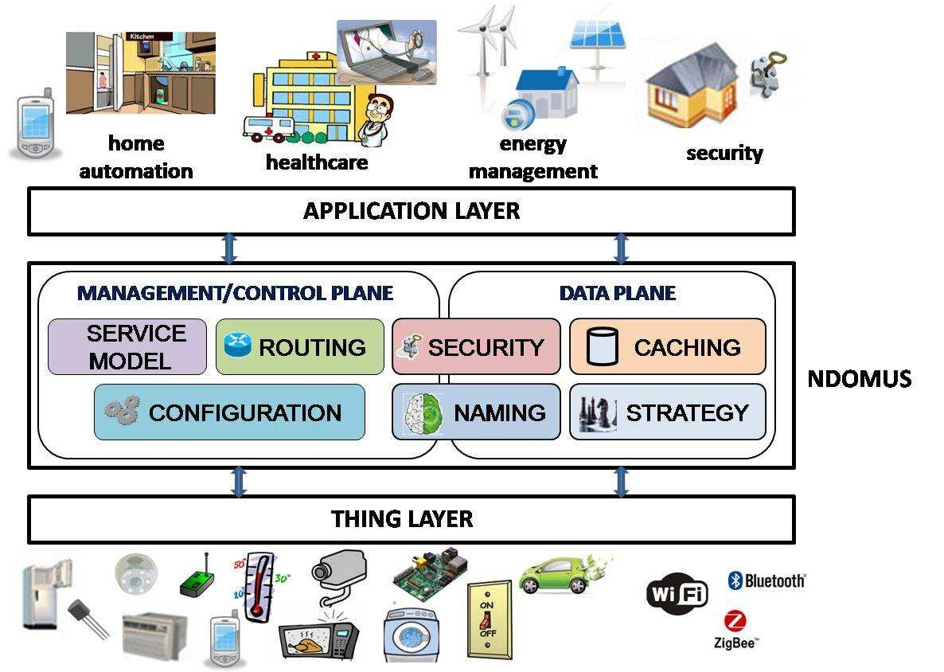

Fig. 1.The NDOMUS framework.[3]

In NDOMUS, application-specific and humanreadablenames support both sensing/action andmanagement/configuration operations in the house. Forthis purpose, we identify two sub-namespace classes: (i)Configuration and management namespace, identified bythe prefix /conf, used for home network initialization,configuration updates and management operations; and (ii)Tasknamespace, identified by the prefix /task, used to identifyand enable all the control and monitoring operations.NDOMUS adopts the following basic name structure:/homeID/task/type/subtype/location/, where the type componentspecifies the task type (sensing or action); the subtypecomponent describes which specific sensing or action taskmust be performed (e.g., temperature sensing); and the locationcomponent identifies the physical position of the ED inthe house.
ICN holds great promise for building smart home managementsystems, because it simplifies network configuration,data retrieval, and service access, and also provides inherentlysecurity at the network layer.
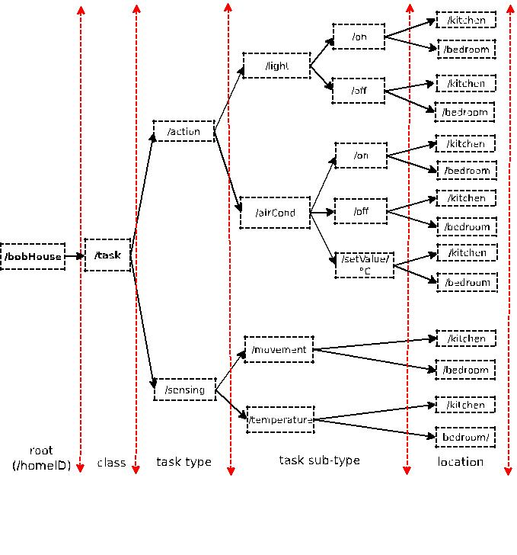
Fig. 2. Name tree example for task sub-namespace[3]

2.4 MACHINE TO MACHINE COMMUNICATION (M2M)
2.4.1 INTRODUCTION
The communication industry has seen a tremendous growth over the last two decades. Machine-to-machine (M2M) communications is an emerging communication paradigm that provides ubiquitous connectivity between devices along with an ability to communicate autonomously requiring no human intervention.
The most prominent M2M application areas include security and public safety (surveillancesystems, alarms, etc.), smart grids (grid control), vehicular telematics (enhanced navigation, etc.), healthcare (telemedicine, remote diagnosis, etc.), manufacturing (production chain monitoring), and remote maintenance (industrial automation, etc.). M2M networks can be divided into two broad domains: 1) capillary M2M and2) cellular M2M networks. In capillary M2M networks, M2M devices form a device area network wherein connectivity is provided through short-range communication technologies (such as ZigBee and Wi-Fi). Wide area connectivity is provided through a gateway. [4]
In cellular M2M networks, M2M devices are equipped with embedded SIM cards and have the ability of communicating autonomously with the cellular network like a normal user equipment.
COGNITIVE M2M COMMUNICATION:
Cognitive M2M communications (M2M communications employing cognitive radio technology)is expected to be indispensable in the era of IoT.Throughdynamic spectrum access capabilities, cognitive M2M not only improves spectrum utilization but also exploits alternate spectrum opportunities. In addition, cognitive M2M is inherently equipped to address the challenges of interference management, energy efficiency, and device heterogeneity. Moreover, cognitive M2M opens new application areas for M2M communications.Cognitive radio technology provides as a novel approach to address the spectrum scarcity and spectrum inefficiency issue in wireless networks. In cognitive radio networks, unlicensed users (secondary users) dynamically access the frequency band/channel whenever the licensed user [primary user (PU)] is absent and need to vacate the band/channel whenever the latter is detected.[4]
PROTOCOL STACK FOR M2M:
Technically viable communication architecture is crucial for the realization of IoT. The community has a consensus for the need of a standardized architecture which replaces proprietary approaches by means of a transparent end-to-end architecture. This section presents a standardized protocol stack forM2M communications. The core requirements of the protocol stack for M2M communications include the following:
- Energy-efficient protocol stack: Majority of M2M devices are battery-operated and do not have the ability to draw power from the mains. Moreover, they are often deployed in areas where frequent human access, and hence battery replacement is not always feasible. Therefore, the protocol stack must exhibit low energy consumption.
- Internet-enabled protocol stack: It is of paramount importance that M2M networks are Internet protocol (IP)-enabled, so that M2M devices have a universal language for communication.
- Highly reliable protocol stack: Most M2M networks are inherently lossy in nature owing to operation in challenging wireless environments with frequent link failures. Hence, reliability must be ensured at different layers of the protocol stack.[4]

2.5 EASYCONNECT
2.5.1 INTRODUCTION
In the recent years, many Internet of Things (IoT) devices (including the wearable devices) have been used in applications for money flow, logistics flow, people flow, interactive art design, and so on. To manage these increasing disparate devices and connectivity options, ETSI has specified end-to-end machine-to-machine (M2M) system architecture for IoT applications.
An IoT device can be characterized by its functionalities or “features.” For the purpose of description, this paper defines a feature as a specific input or output “capability” of the IoT device.For example, a wearable ring with the temperature sensor has the input device feature (IDF) called “temperature” (abbreviated as T-IDF). A pair of wearable glasses with the optical head-mounted display has the output device feature (ODF) called “display” (abbreviated as D-IDF). An IoT device may be connected to the network (i.e., Internet) using wireless communications directly or indirectly through a smart phone. If so, the corresponding software called network application is developed and executed by a server in the network side, which receives or sends the messages from/to the IoT device. When the values of the IDFs are updated, the IoT device will inform the network application to take some actions, and the network application may send the result to the ODF of an IoT device. With this view, the IoT devices interact with each other through their features, and we say that the network application “maps” the IDFs to the ODFs.
If a network application handles the individual device features independently, then we can write a software module for each device feature, and the network application can be simply constructed by including these brick-like DF modules. IDF module computes, e.g., the variation of acceleration, and passes the result to the V-ODF module.ODF module translates the received value to vibration intensity. If the IDF and the ODF modules are independent of each other, then these software modules can be reused to build the network applications, and effectively speed up the development of the IoT applications.[5]
Brick-like software modules can provide efficient and simple mechanism to develop IoT device applications and communications. Specifically, we develop an IoT Easy Connectsystem to achieve this goal.

CHAPTER 3
Discussion and Analysis
3.1 OVERVIEW
Recent innovations in the ICT(Information and Communication Technology) field are strongly focused towards the Internet of Things, which will definitely lead to an enhancement also in the domestic environments. Low- power and low-cost devices are expected to create a network of interconnected smart objects able to transform our homes into real Smart Homes. However, the heterogeneity of the underlying technologies prevents these smart objects to natively interoperate for adapting the environment to users’ needs.
Many Internet of Things (IoT) technologies have been used in applications for money flow, logistics flow, people flow, interactive art design, and so on. Based on machine-to-machine(M2M) architecture for IoT applications, we develop an IoTEasy Connect system to manage disparate IoT devices. In our approach, an IoT device is characterized by its “features” (e.g., temperature, vibration, and display) that are manipulated by the network applications. Machine-to-machine (M2M) communications enables networked devices to exchange information among each other and therefore creates what is known as the Internet-of-Things (IoT).It is expected that cognitive M2M communications will be indispensable in order to realize the vision of IoT.
To support and assist an individual in performing a variety of everyday tasks within his/her living space we can make use of Smart-Home. Since location and movement constitute meaningful evidence for many everyday tasks, we are motivated to develop an efficient, accurate, and non-invasive occupant-localization method.
3.2 EXPLICATION
Information-centric networking (ICN) is an approach to evolve the Internet infrastructure away from a host-centric paradigm based on perpetual connectivity and the end-to-end principle, to a network architecture in which the focal point is “named information” (or content or data). In this paradigm, connectivity may well be intermittent, end-host and in-network storage can be capitalized upon transparently, as bits in the network and on storage devices have exactly the same value, mobility and multi access are the norm and any cast, multicast, and broadcast are natively supported. Data becomes independent from location, application, storage, and means of transportation, enabling in-network caching and replication. The expected benefits are improved efficiency, better scalability with respect to information/bandwidth demand and better robustness in challenging communication scenarios.[3]
ADVANTAGES OF ICN FRAMEWORK:
- Simplifies network use - reduces set-up time and doesn't require manual configuration through firewalls, VPNs, and ad hoc synchronization protocols.
- Provides a seamless, ubiquitous experience - allows people to easily send and receive digital content from multiple locations, mobile devices, and diverse networks.
- Reduces congestion and latency - doesn't send irrelevant or redundant information through network pipelines.
- Improves network performance while reducing operating costs - increases efficiency by at least three orders of magnitude.
- Increases network reliability - robustly delivers information using any available medium.
- Eliminates many security problems - secures information so integrity and trust are properties of the content, not of the channel.
- Supports new and emerging applications - facilitates mobile and wireless access (which are currently relegated to the fringe of the network), and enables broadcast, voice over IP (VoIP), autonomous sensor networks, ubiquitous applications, and context-aware computing.
- Empowers the user - allows people to express intent to their networks (e.g., to prioritize specific content over others) and prioritizes their needs from inside the network.
In order to better illustrate the behavior and benefits of our ICN-based framework, we provide following scenario:
We consider the reference use case in Fig. 2 for an initial performance comparison between NDOMUS and potential alternatives (CoAP, NDN) in terms of number of exchanged packets. This simple metric is considered critical in the reference scenario, since it gives information about both the used network resources (limited in wireless environments and close to be exhausted in the core network) and the devices’ energy consumption (serious for resource-constrained devices). For the sake of simplicity, we assume that (i) no packet losses occur and (ii) the size of each exchanged packet ﬁts the typical payload constraints of IoT access technologies and is similar for CoAP (including 6LoWPAN/UDP header), NDN, and NDOMUS, by neglecting security aspects [9], thus represents not a decisive factor in the differences observed in the following experiments.

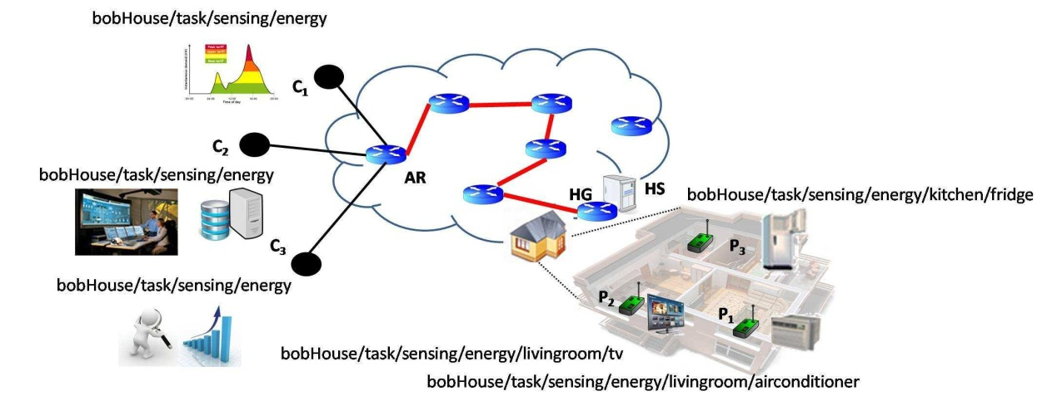

Fig 3Reference smart home scenario with several consumers and producers.[2]

A number of C remote consumers request home energy consumption data for different purposes (e.g., real-time energy billing and distribution purposes, long-term analytics and proﬁling). We assume that the consumers are connected to the same access router (AR), which is linked to the HS through N wired links of the core network1. Upon receiving the requests from the remote consumers, the HS queries all P metering devices embedded into home appliances and sends back a packet conveying the collected data, aggregated according to some rules agreed with the utility companies. In the considered example in Fig. 2, C=3, P =3 and N=5.
When a CoAP-like solution running over 6LoWPAN is implemented, the typical HTTP request/response interaction is used, which is based on the standard GET and PUT methods. The requested resource (i.e., the measurement from a given meter) is identiﬁed by a Uniform Resource Identiﬁer (URI). Some resources can be saved over the wireless link since in CoAP the HS issues a single request to simultaneously get responses from multiple producers, by leveraging IP multicasting. Moreover, the HS acts as a CoAP proxy and can cache data to satisfy requests from different consumers. The resulting number of exchanged packets is: NCOAP = 2C + 2CN + (1 + P). The ﬁrst term accounts for request/response packets over the consumer-AR link, the second one for the request/response messages over the N common wired links for each consumer (IP is data-agnostic and does not identify requests to the same resource object), and the third contribution accounts for the number of requests and replies (respectively, 1 and P, thanks to caching in the HS) over the wireless link.
NDOMUS operates like the plain NDN until the single aggregated Interest arrives to the HS, then the HS with a single Interest broadcasted over the wireless link gets back individual replies from the P metering devices in the house. Each producer replies with a Data packet carrying a name that combines the prefix in the Interest bobHouse/task/sensing/energy/
with the producer-speciﬁc component that uniquely identiﬁes it, e.g., kitchen/fridge. Once the HS receives all the Data from the P producers (whose identity and number is supposed known from the conﬁguration phase), it sends back a single aggregated Data packet to the remote consumers. The number of exchanged packets is: NNDOMUS = 2C + 2N + 1 + P.

PROTOCOL LAYER FOR COGNITIVE M2M

Protocol stack for (capillary) M2M communications and cognitive M2M communications.[4]

PHY LAYER FOR COGNITIVE M2M:
The IEEE 802.15.4m TG provides the PHY layer specifications for cognitive M2M networksworking in TVWS. Till date, seven different PHY layer designs in seven different regulatory domain-specific frequency bands.. However, these designs are mainly from modulation and coding perspectives only.

MAC LAYER FOR COGNITIVE M2M:
A)IEEE 802.15.4m
The network topology in an IEEE 802.15.4m-based cognitive M2M network consists of two types of devices: 1) the full function device (FFD), with a complete set of MAC functionalities, and 2) the reduced function device (RFD) with a limited set of functionalities. Multiple devices form a device area network or a personal area network (PAN). Each PAN has a PAN coordinator, which acts like a centralized controller. Devices inside a PAN are connected through a master–slave connectivity as shown in Fig. 2. The FFDs having the capabilities of becoming coordinators can be further connected to other devices to establish extended hierarchies. In addition to the cluster-tree topology, device-to-device connectivity is also possible, i.e., devices within the same hierarchy are able to directly connect to one another. The master device is responsible for enabling the operation of associated slave devices. The master device obtains the channel availability information and sends an enabling signal. Devices in a PAN periodically scan for the enabling signal and register with the master device upon reception.

Fig 4.Network topology in IEEE 802.15.4m.[4]

NETWORK LAYER FOR COGNITIVE M2M:
CORPL:
RPL is expected to the standard routing protocol for majority of M2M applications. In this regard, an enhanced RPL-based routing protocol for cognitive radio enabled M2M networks has been proposed in .The main objective of the proposed protocol, termed as cognitive and opportunistic (CO)RPL, is to retain the directedacyclic graph (DAG)-based approach of RPL and at the same time introduce novel modifications to allow its application in CR environments. To address the aforementioned challenges, CORPL uses an opportunistic forwarding approach that consists of two key steps: 1) selection of a forwarder set, i.e., each node in the network selects multiple next hop neighbours and 2) a coordination scheme to ensure that only the bestreceiver of each packet forwards it (unique forwarder selection). In CORPL, each node maintains a forwarder set such that the forwarding node (next hop) is opportunistically selected.
The DAG construction process in CORPL follows a similar procedure as in RPL. After detecting a vacant channel, the gateway node transmits a destination information object (DIO) message. CORPL uses expected transmission count (ETX) as the default metric for rank computation. The ETX of a link will be measured and updated continuously, once the link starts to carry data traffic. The forwarder set is constructed in such a way that the forwarding nodes are within the transmission range of each other. During the DIO transmission, each node also reports some additional information using the option field of the DIO message. Each node updates the neighbourhood information through the DIO message transmission. Based upon the neighbourhood information, each node dynamically prioritizes its neighbours in order to construct the forwarder list. The priorities are assigned according to a cost function. The cost function to prioritize the nodes in the forwarder set depends on the routing class. CORPL considers two different routing classes. The first class (class A) assigns a greater importance to PU receiver protection; whereas, in second class (class B), the end-to-end latency is the key consideration forsupporting the high priority delay sensitive alarms.
CORPL employs two different techniques for mitigating theperformance degradation due to spectrum sensing. The first technique improves the performance through gathering sensing schedule information of the neighbouring nodes. The second technique improves performance by decreasing the spectrum sensing time. Reduction of sensing time is possible when a node is situated in region of low PU activity, and hence the number of channel changes that occur over time is small.
TRANSPORT LAYER AND ABOVE FOR COGNITIVE M2M:
In literature, the problem of adapting conventional transport layer protocols (TCP and UDP) for cognitive M2M networks has been rarely investigated. For general cognitive radio ad hoc networks (CRAHNs), a transport protocol . The proposed protocol, termed as TP-CRAHN (transport protocol for CRAHNs), adapts TCP for cognitive radio environments. TP-CRAHN is specially designed considering the peculiarities of cognitive radio environments and explicitly accounts for the periodic spectrum sensing, PU activity, channel availability, and bandwidth variations. The protocol integrates as an end-to-end metric, the spectrum sensing, and switchingfunctionalities in a cognitive radio network, apart from the classical concerns of congestion, flow control, and connection losses due to node mobility. By relying on updates from the intermediate nodes and the destination feedback, the source maintains information about the network state and responds appropriately by adjusting its transmission rate. TP-CRAHN provides valuable insights for adapting TCP and other transport layer protocols for cognitive M2M networks.[4]
The cognitive radio-based PHY layer does not require any changes at the application layer. Although cognitive M2M introduces a variety of new applications, CoAPis expected to be the standard application layer protocol.

We compare three placement strategies: 1) placements generated by our algorithm, i.e., optimized; 2) placements crafted manually; and 3) randomized placements. The following subsections describe the placement generation in more detail.
1) Optimized Placements: According to our reasoning in Section V-A, the localization accuracy of optimized placements greatly depends on the selected cmax value (maximum preferable coverage utility). Having performed a number of visual tests on the boundary cases, i.e., placements of 5 and 20 nodes, we narrowed down a possible range of cmax values to a set of {3, 4, 5}. This choice was based on the following observations: with cmax<3 the impact of coverage utility assignment on the results of the placement algorithm is hardly noticeable; with cmax>5 we observed oversaturation of sensors in high-priority areas while some low-priority areas did not get covered at all even with the significant budget of 20 sensors. Next, we generated three placements, i.e., with cmax=3, 4, 5, for each k = 5, . . . ,20 and tested them against the artificial traces.2 Fig. 13 shows the average localization error for each placement in relation to the cmax value. Although in some cases the data points coincide (e.g., cmax= 3 and cmax= 4 for 11 and 17–20 sensors), we observe a general trend: lower error rates are achieved with cmax= 4 for k ≤ 11 sensors and with cmax= 5 for 11 < k ≤ 20. This trend confirms our intuition that cmax grows with k. It is worth noting that k = 11 is an important threshold: this is the largest number of sensors that can cover the majority of the space (excluding furniture) without overlap, i.e., this number is obtained by dividing the total walkable area (area of the floor plan without nonwalkable obstacles) by the area of a sensor footprint. Once we have a budget of more than 11 sensors we cannot avoid overlapping. Hence, it is natural to increase the value of cmax for all k >11. In all subsequent experiments, we use the optimized placements chosen according to the observed trend, i.e., those generated with cmax= 4 for k ≤ 11 and cmax= 5 for 11 < k ≤ 20.[4]

2) Manual Placements: We assume that the expert designing a placement is inclined to maximize total coverage without specific considerations for the area occupied by furniture. Typically, we want to distribute sensors uniformly so that the amount of uncertainty about the occupant’s location is also uniformly distributed across the space, even if the budget of sensors is not sufficient for full coverage. Given more sensors than necessary for full coverage, one would likely attempt to design placements with a fairly regular “grid” of overlapping regions. Fig shows two examples of manually crafted placements: nine sensors, uniformly covering the space with gaps between sensors, and 20 sensors, regularly overlapping. We manually designed 15 placements for each k = 5, . . . ,20 following the aforementioned considerations. Our final goal was to compare the performance of the optimized placements against manual placements on the traces of the typical daily routine. But first we would like to show that our manual placements are designed without a bias toward a particular data set. We generated a number of traces that systematically cover the entire space in a zigzag-like fashion . The assumed model of the space used for these traces is different from the initial model: it consists of the walls solely (no furniture). Essentially, we attempt to generate traffic of uniform density across the whole space and show that the optimized placements have no advantage over the manual placements on the uniformly-distributed mobility data. Fig. 7 compares the performance of manual against optimized placements on “zigzag” traces. We can see that the manual placements outperform the optimized ones for all k = 5, . . . ,20. The unpaired t-test shows that the difference between the two types of placements is statistically significant for all k except k = 7. This exercise suggests that the manual placements are well-designed and can be considered good candidates for a comparison with the optimized placements when tested on the daily-routine traces.
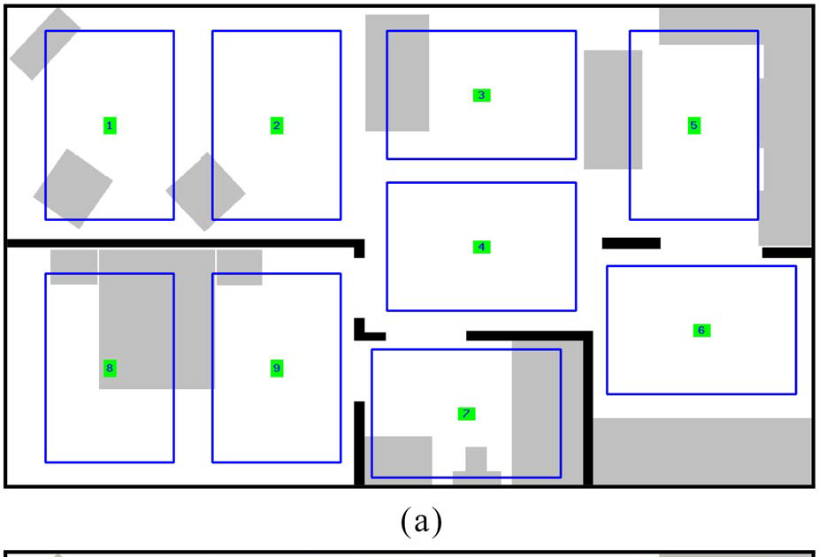
Fig [4]

3) Randomized Placements: As a performance baseline, wegenerated five randomized placements for each k = 5, . . . ,20. In the subsequent sections, wereport localization error of the kth randomized placement asthe average of 5 placements generated for every k, each testedon ten daily-routine traces.

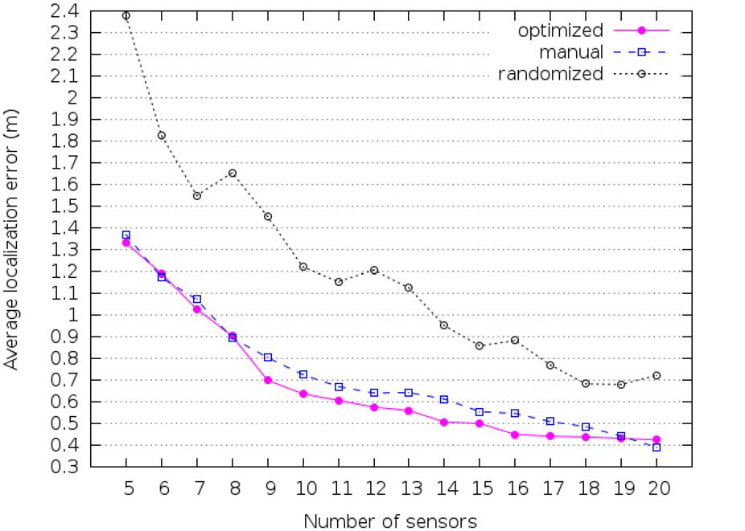
Fig 6 [5]

4. CONCLUSION AND FUTURE SCOPE

4.1 CONCLUSION
The Smart-Condo project aims to support people withchronic conditions to live independently at home, longer. Ourapproach has emphasized a privacy-respecting and nonintrusivemonitoring infrastructure comprised of sensors, whichcollect an occupant’s activity data, and actuators, which controlhome ambience with the goal of improving the occupant’sliving quality. One of the most valuable sources of data forcaregivers is the occupant’s mobility profile, which can beused for early diagnosis of chronic conditions or simply tobetter deliver intelligent services spatially distributed in theapartment.

4.2 FUTURE SCOPE
The concept of Smart Homes has a very wide future scope. It is an ever increasing concept and can keep growing with the growth of technology. This is just the beginning because there will be apps created to interact with your future home robots to tell them to put food in the oven, clothes in the laundry, feed the cat and clean the bathroom. From your smart phone (or headphone as pictured) you’ll be able to check the supplies in your refrigerator or pantry and order more from the grocery store. Or you’ll use future home automation so that you don’t have to worry about this on a day by day basis as your pre-programmed smart home technology will take care of this for you and you can override it at will by using your phone application.

REFERENCES

[1] An IoT-based User-centric Ecosystem for Heterogeneous Smart Home EnvironmentsLuca Mainetti, Vincenzo Mighali, Luigi Patrono Dept. of Innovation Engineering University of SalentoLecce,ITALY
[2] The Smart-Condo: Optimizing Sensor Placement for Indoor Localization IuliiaVlasenko, IoanisNikolaidis, Member, IEEE, and EleniStroulia, IEEE TRANSACTIONS ON SYSTEMS, MAN, AND CYBERNETICS: SYSTEMS, VOL. 45, NO. 3, MARCH 2015

[3] Information Centric Networking in IoT scenarios: the Case of a Smart Home MaricaAmadeo, Claudia Campolo, Antonio Iera, AntonellaMolinaro

[4] Cognitive Machine-to-Machine Communications for Internet-of-Things: A Protocol Stack PerspectiveAdnan Aijaz, Member, IEEE, and A. Hamid Aghvami, IEEE INTERNET OF THINGS JOURNAL, VOL. 2, NO. 2, APRIL 2015

[5] EasyConnect: A Management System for IoT Devices and Its Applications for Interactive Design and ArtYi-Bing Lin, Fellow, IEEE, Yun-Wei Lin, Chang-Yen Chih, Tzu-Yi Li, Chia-Chun Tai, Yung-Ching Wang,Fuchun Joseph Lin, Hsien-Chung Kuo, Chih-Chieh Huang, and Su-Chu Hsu, IEEE INTERNET OF THINGS JOURNAL, VOL. 2, NO. 6, DECEMBER 2015

